# Mandatory Spire MT Source Control Management System

## A cloud based repository system that is shared for Selected Spire members for:

* File and Documentation Revision/Version Management
  + Just Drag and drop files into a repository folder then check them in and check them out to work on them
* Source Code Version Management
  + For Source Code Versioning

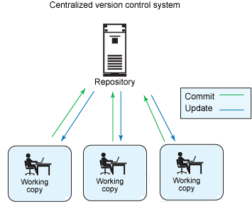

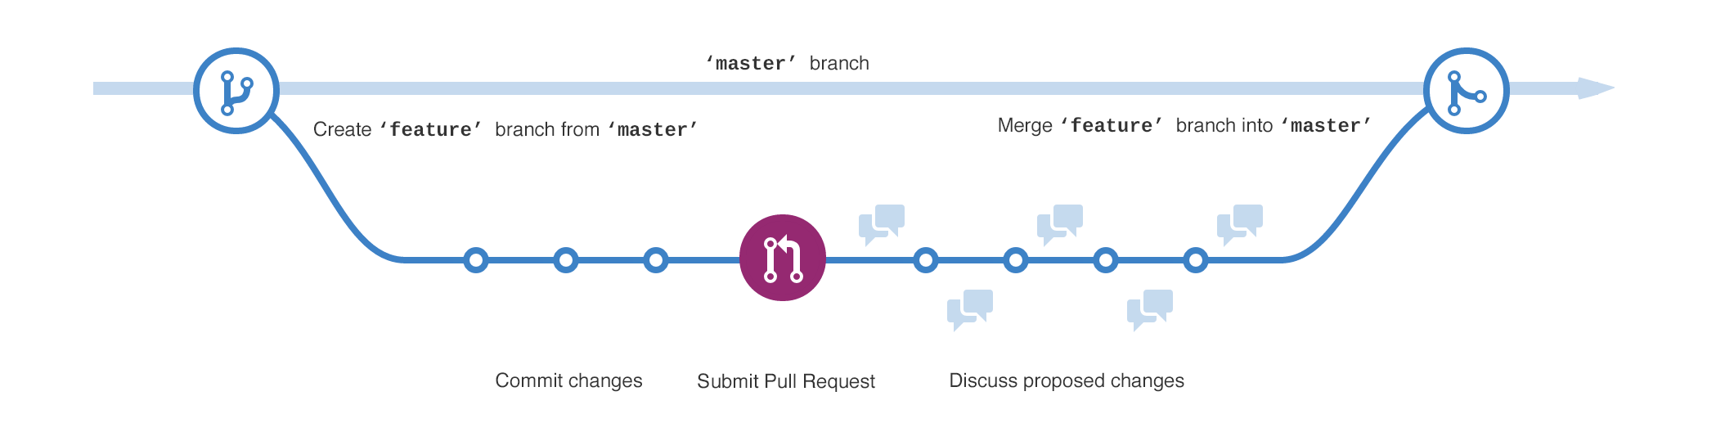

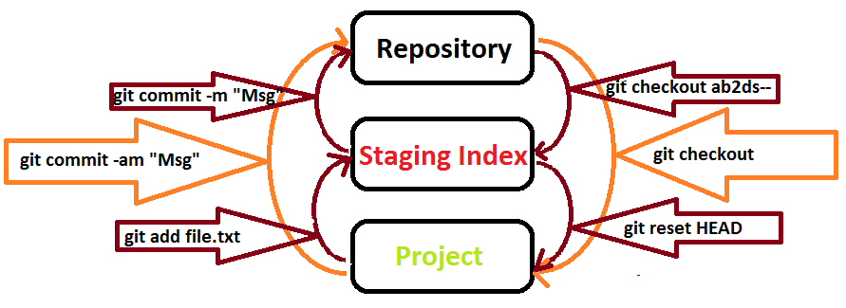

# Spires Source Code Management System

<https://github.com/SpiremtSCM/>

Create an account for this link

# Spire Code repositories/Documentation Repositories are (links):

**SpireOrganizations**

[](https://github.com/SpireMT)

Top of Form

Bottom of Form

[**Edit profile**](https://github.com/account)

**ProTip!** Updating your profile with your name, location, and a profile picture helps other GitHub users get to know you.

[Overview](https://github.com/SpiremtSCM)

Top of Form

Type: All

Language: All –Just Click on Repository Link Below These [**New**](https://github.com/new) **Spire Repositories** for Source code and Documentation Control (Checkin/Checkout)

Click link and Start Adding Source or documentation, these Spire Repositories will be point of record for all future information and will be the MASTER point of orgigen for spire source code and Documentation

* **[Spire-Product-Datasheets](https://github.com/SpiremtSCM/Spire-Product-Datasheets)**

[Spire-Product-Datasheets](https://github.com/SpiremtSCM/Spire-Product-Datasheets)

* [**Spire-EF10-TP10**](https://github.com/SpiremtSCM/Spire-EF10-TP10)

Spire EF10-TP10

* **[Spire-EF40](https://github.com/SpiremtSCM/Spire-EF40)**

Spire EF40

* [**Spire-EF12**](https://github.com/SpiremtSCM/Spire-EF12)

Spire EF12

* [**Spire-280T-S**](https://github.com/SpiremtSCM/Spire-280T-S)

Spire 280T-S

* [**Spire-280W-D--CI**](https://github.com/SpiremtSCM/Spire-280W-D--CI)

Spire 280W-D--CI

* [**Spire-280W-R**](https://github.com/SpiremtSCM/Spire-280W-R)

Spire 280W-R

* [**Spire-MAG888--Flowmeter**](https://github.com/SpiremtSCM/Spire-MAG888--Flowmeter)

Spire MAG888--Flowmeter

* [**Spire-MAG-888-DC**](https://github.com/SpiremtSCM/Spire-MAG-888-DC)

Spire MAG-888-DC

* [**Spire-T-MAG-BTU**](https://github.com/SpiremtSCM/Spire-T-MAG-BTU)

Spire T-MAG-BTU

* [**Spire-280T**](https://github.com/SpiremtSCM/Spire-280T)

Spire 280T

* [**Spire-280WR**](https://github.com/SpiremtSCM/Spire-280WR)

Spire 280WR

* [**Spire-280WCI**](https://github.com/SpiremtSCM/Spire-280WCI)

Spire 280WCI

Spire Product-Datasheets

**Spire File Revision Management**

**Manuals, Folders, Documents, Datasheets**

For files that need to be stored and check in and out under Version Management

## Create an Account

Go to this link install github using this **link below** and Create an account as shown below. Location to download and install github

Below

<https://github.com/SpiremtSCM/>



Once you have done so let me know and I will add you to the **SpireSCM Respositories in System**

**example** Create Github user as Spire[Shuangshen](mailto:Shuang.shen@spiremt.com.cn)

Using your spire email [Shuang.shen@spiremt.com.cn](mailto:Shuang.shen@spiremt.com.cn)

Or SpireTimChen

[Tim.chen@spiremt.com.cn](mailto:Tim.chen@spiremt.com.cn)

For Drag and Drop Files to be Checked in/out go here and install this https://git-for-windows.github.io/

**Once Github is setup you will have an icon on your desktop that looks like this**

double click to launch it for storing code or click on a Spire repository link above

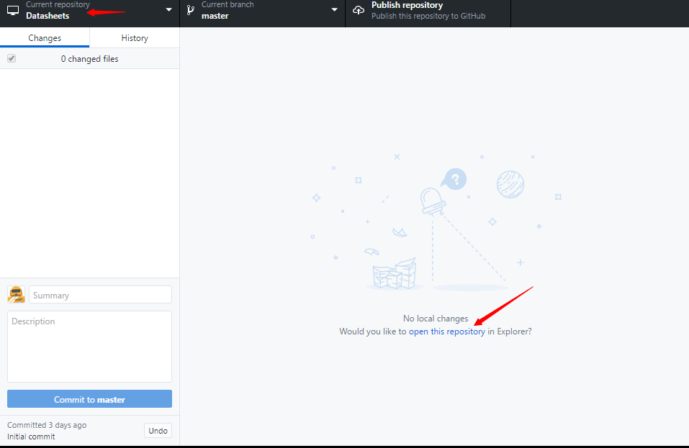

# <https://github.com/SpiremtSCM/GVFS>

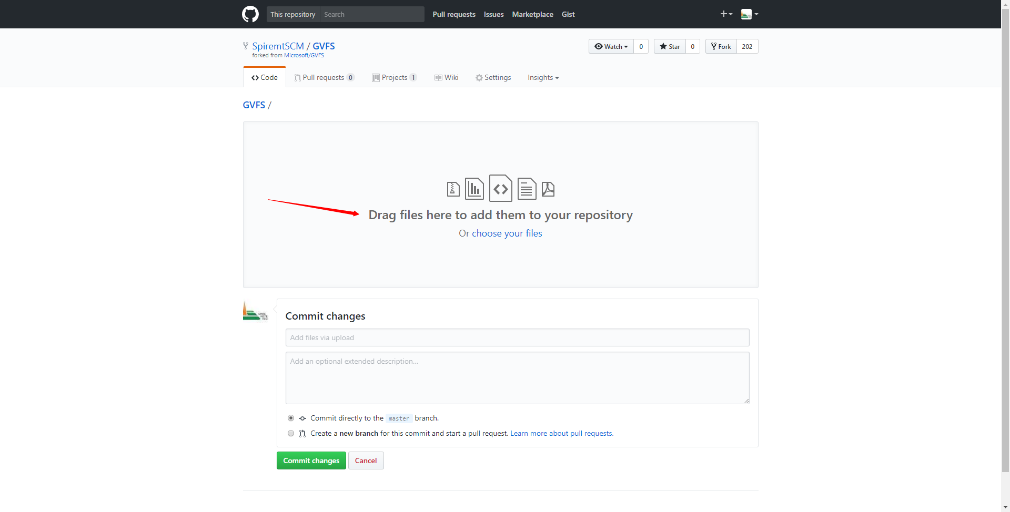

## Coders may want to use this - What is GVFS?

GVFS stands for Git Virtual File System. GVFS virtualizes the file system beneath your git repo so that git and all tools see what appears to be a normal repo, but GVFS only downloads objects as they are needed. GVFS also manages git's sparse-checkout to ensure that git operations like status, checkout, etc., can be as quick as possible because they will only consider the files that the user has accessed, not all files in the repo.

GVFS is still in progress, but it is available here for anyone to try out. Feel free to send us feedback, bug reports, suggestions, and pull requests!

## Building GVFS

* Install Visual Studio 2017 Community Edition or higher (<https://www.visualstudio.com/downloads/>). Include the ".Net desktop development" and "Desktop development with C++" workloads, as well as the following additional components:
  + .Net Framework 3.5 development tools
  + C++/CLI support
  + VC++ 2015.3 v140 toolset
  + Windows 10 SDK (10.0.10240.0)
* Install InnoSetup 5.5.9 or later (<http://www.jrsoftware.org/isdl.php>) to its default location (or you'll have to change the path in GVFS.csproj post-build step to match)
* Create a folder to clone into, e.g. C:\Repos\GVFS
* Clone this repo into the src subfolder, e.g. C:\Repos\GVFS\src
* Open src\GVFS.sln in Visual Studio. Do not upgrade any projects.
* Build GVFS.sln